**Finding the Focal Length of Lenses**

Aim: To draw ray diagrams for lenses and use those diagrams to find the focal point and focal length of the lens

Equipment:

* Hodson light box
* Power Pack
* Lenses (one concave, one convex with high curvature, one convex with low curvature)
* Multiple slit slide (3 slits)
* Pencil and ruler

Method:

1. Connect the light box to the power pack.
2. Place the multiple slit slide in the light box.
3. Put the light box on the place indicated below.
4. Put the convex lens with low curvature in the path of the light rays.
5. Mark the position of the lens, by drawing around the lens.
6. Use a pencil to mark two dots for each incident and refracted ray on the sheet of paper.
7. Remove the lens and draw these rays onto the page.
8. Mark the focal point of the lens and measure the focal length (from the centre of the lens.
9. Repeat steps 3 to 8 for the convex lens with high curvature and the concave lens.

Results:

**Convex lens** – low curvature

Put light box here

Focal length = ______________

**Convex lens** – high curvature

Put light box here

Focal length = ______________

**Concave lens**

Put light box here

Focal length = ______________

Discussion:

1. Describe the effect of a convex lens on parallel light rays.
2. Describe the effect of a concave lens on parallel light rays.
3. Compare the path of light through a wide convex lens with that of a thin convex lens.
4. How does the shape of a convex lens affect the focal length of the lens?

**Investigating Images formed with a Convex Lens**

Aim: To investigate the images formed by a convex lens

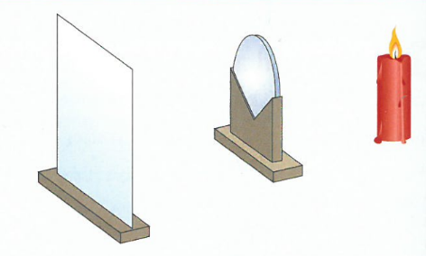Equipment:

* Convex lens (focal length = 20cm)
* Lens holder
* Candle
* White paper on a clipboard for a screen
* Petri-dish
* Blu-tac or plasticine

Method:

1. Use the blu-tac to stick the candle in the petri-dish.
2. Place the lens in the lens holder.
3. Set up the apparatus as shown in the image above.
4. Place the candle 50cm away from the lens.
5. Light the candle.
6. Moving the screen only, find the sharpest possible image of the candle on the screen.
7. Measure the distance from the lens to the screen and record it in the table below.
8. Describe the image formed in words and add that to the table as well.
9. Repeat steps 4 to 8, changing the distance between the candle and the lens to 40cm, 30cm, 20cm and 10 cm.

Results:

|  |  |  |  |  |
| --- | --- | --- | --- | --- |
| Convex Lens Focal Length = 20cm | | | | |
| **Object** | | | **Image** | |
| Diagram | Description of Position | Distance From Lens (cm) | Distance from Lens (cm) | Description of Image |
|  | Object more than two focal lengths from lens | 50 |  |  |
|  | Object two focal lengths from lens | 40 |  |  |
|  | Object between one and two focal lengths from lens | 30 |  |  |
|  | Object at focal length of lens | 20 |  |  |
|  | Object less than one focal length from lens | 10 |  |  |

Discussion:

1. Describe what happened to the image as the object was brought closer to the lens, but still outside the focal length? (Hint: look at your results for 50cm, 40cm & 30cm)
2. Was it possible to form an image when the candle was at the focal point of the lens? Describe what you saw. (Hint: look at your results for 20cm)
3. Describe what happened to the image when the object was inside one focal length of the lens. (Hint: look at your results for 10cm)
4. From your experimental results when is:
   1. A real image formed?
   2. A virtual image formed?
   3. No image formed?